Buddhism and Me!
Brandy Gibbons
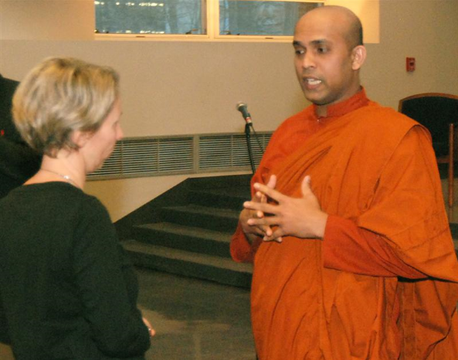
Bhante Pemaratana talks to an audience member after his lecture Friday evening in the
Pasquerilla Spiritual Center. Nigel Graham/Collegian
Buddhism isn’t a culture that necessarily “scared” me, and I wouldn’t say I had a predisposed dislike for Buddhists, but I didn’t quite understand the religion, or maybe I should say the culture. Lots of people have this mystified idea of Buddhism, but don’t actually know very much about it. I learned a bit about Buddhism in a high school World Cultures class, but I became very interested in the past few months, so I scheduled an Intro to Buddhism class, RL ST 104, which I’m currently taking. As you would expect, we’re learning about the history of Buddhism and how Buddha obtained his enlightenment under a Bodhi tree, but I wanted more. When I started to think about this assignment, I decided I wanted to explore that culture a little more. I looked for places to go on Google, but that wasn’t very easy. There’s not a very heavy Buddhist culture in State College, or so it seems. Most places wanted only newcomers with previous experience with meditation, and I definitely hadn’t meditated before. Well, I found an article on the Penn State Newswire that said a Buddhist Monk, Bhante Pemaratana, from the Pittsburgh Buddhist Center, was to speak here last Friday with an intro to meditation session at the end. Even better, Bhante was to talk about how to manage negative emotions, which, I feel, is a huge weakness of mine, so I knew it would be well worth it. Bhante explained what negative emotions are (mental states that bring about affliction to oneself or others) and that it’s unhealthy to express these emotions while it’s also unhealthy to suppress them, too. The real answer was to manage and channel the emotions. His technique for dealing with the emotions was RAISE: Recognition, Acceptance, Investigation, Substitute, and Empathy. In order to manage negative emotions, we need to first recognize and be aware of the change in our emotions or catch the physical changes that occur when a negative emotion is occurring. We, then, need to accept the emotion or be okay with it; we should allow the emotion to exist within us without disturbing or engaging in it. Then, we need to investigate the emotion, and discover the root of the emotion. After analyzing the emotion, we should focus on alternative ways of looking at the situation—find something positive in the situation. Finally, we need to forgive ourselves and others. We should reduce our expectations and understand the difficulty of others. A great example of this would be a situation where someone snapped at you. We might be tempted to get upset and start forming thoughts that only worsen or justify the emotion, when maybe the person was in deep thought about something negative and accidentally let the emotion afflict us. After Bhante’s talk, there was an optional half hour long introduction to meditation session, which was very cool. Here, I also found out that there’s a new group doing daily meditation sessions at the Pasquerilla Center: The Open Meditation Society. I think I’ll start attending that at least once a week and explore the religion more. After the meditation, I stayed and chatted with one of the other members of the Pittsburgh Buddhist Center who had traveled to Penn State with Bhante. We talked about the differences in the types of Buddhism and how each one interacts with each other. I was unaware that there were so many divisions, like how there is in Christianity. Then, I started talking with another woman who was just recently ordained into Therevada Buddhism, which is the most traditional form. We talked a lot about the type of culture of Buddhism, where it began in America and how it’s portrayed. We exchanged email addresses, and I’m extremely excited to keep in contact with her. I would very much like to practice Buddhism and potentially convert, but she and a Buddhist friend tell me it’s not necessary to formally convert. I definitely love the ideology, and I’m very excited to try the Open Meditation.

